
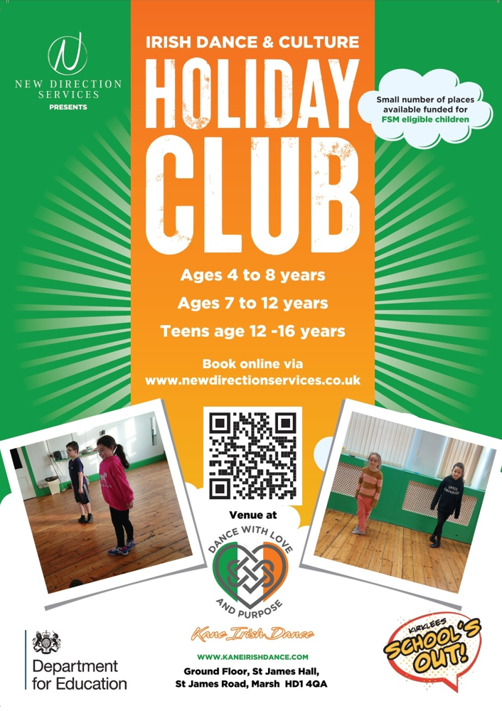

#HAF22
Christmas Holiday Club @RABC BOXING CLUB 
Tanyard Road, Milnsbridge, HD3 4NF
Free to all in receipt of FSM, £10 per child if not.
Lunch & refreshments provided
Youth Club Activities, Boxing training, Fun & Games
11am-3pm December 19th,20th,21st & 22nd
AGE: 8 years-12 years
To register: Please send your child’s name, age, address & Contact details to markleftjab@hotmail.co.uk
07747846977

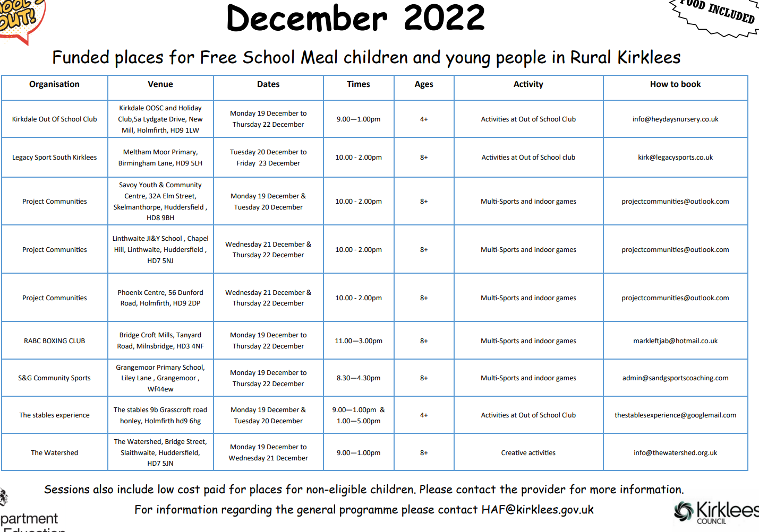

Jubilee Christmas Events
Nobody should be alone or without a meal on any day of the year, and there is lots going on in Hudds to try and combat that, but Christmas Day can be especially lonely in those circumstances.
Please, please share this event with people you know may be alone or struggling for food this Christmas.







