START – How to Guide
Log onto START - https://login.startprofile.com/Login.aspx?redirecto=
Enter your username and password which is in this letter.
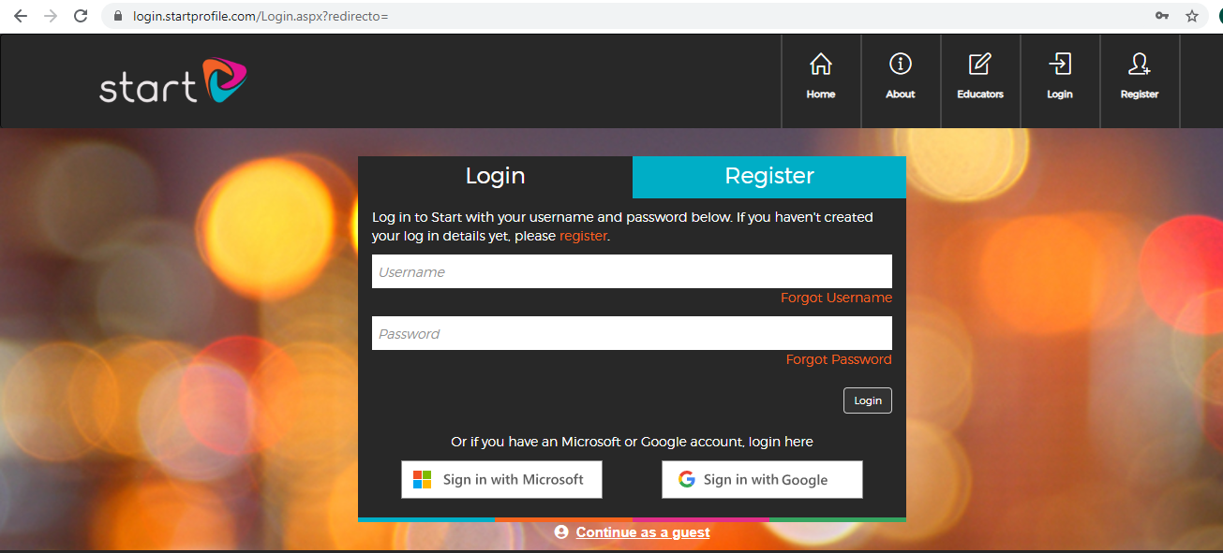

When you have logged in click on My Profile
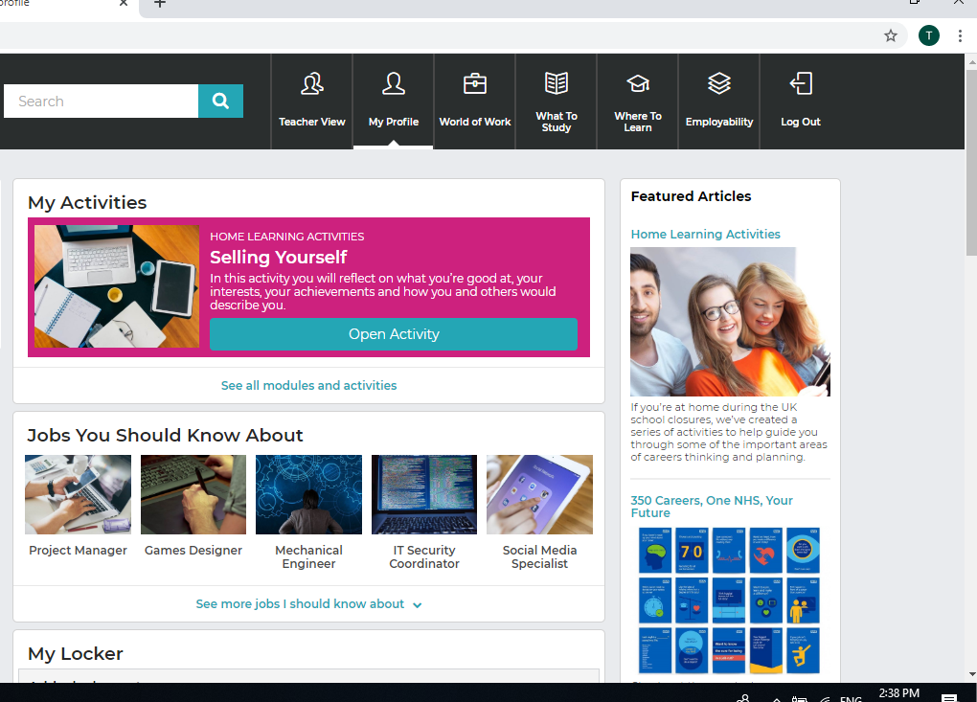
Complete the home learning activity – Selling Yourself

Click on My Profile again and look at the left hand side. Complete About Me and My Likes. You also need to start adding things to My Locker.
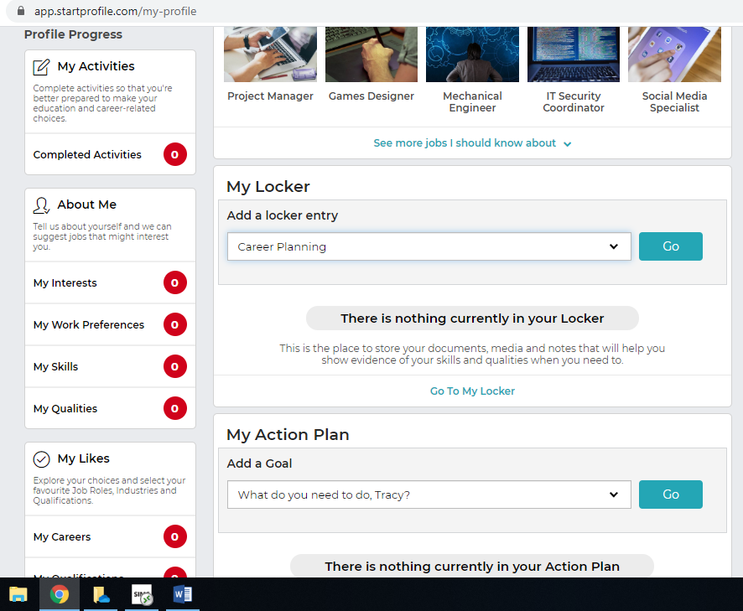
My Locker
Here you can add any extra curricular activities you take part in, work experience, voluntary work, your interests and any careers related guidance you have had. Please add the CV workshops you took part in under the section Visit from Employer.
Complete these

World of Work and What to Study
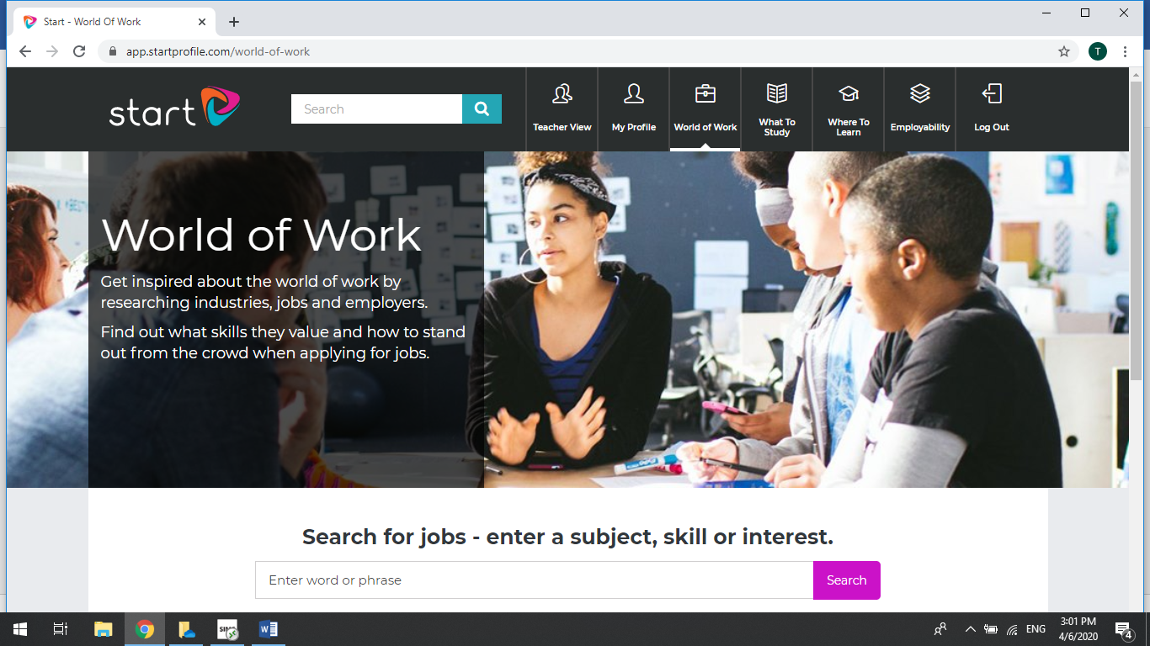
On the world of work section of the platform you can search for jobs, subjects that interest you or particular skills. On the What to Study section you can look at different pathways and different types of qualifications for both post 16 and post 18. These are particularly useful sections that you can explore freely.

