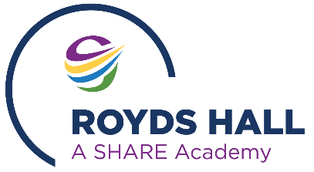
Year 11 destinations - Royds Hall School

Assessing the impact of our careers programme

Our careers programme is continually reviewed to ensure it continues to meet the needs of our students and the Gatsby Benchmarks. This is by means of:
- Student feedback following career activities
- Provider evaluations
- Annual internal review of the careers programme
- Post 16 destination data

Destination Data
After GCSE results day the Careers Adviser contacted the Year 11 leavers, parents, colleges and training providers to confirm destination outcomes. The Careers Department also provided extra support on exam results day to discuss alternative courses or college options if students’ GCSE grades were not what they needed for their first choice.
Please find below details of student destination data for Royds Hall leavers.
This measures the number of students who stayed in education, training or an apprenticeship after Year 11.

Year 11 destinations - Royds Hall School 2021 to 2025

 | Results | Results | Results | Results | Results
Year 11 Destinations | 2021 | 2022 | 2023 | 2024 | 2025
DESTINATIONS
% Post 16 Education | 95.15% | 99.38% | 89.47% | 96.1% | 96.11
% Apprenticeship | 1.21% | 0.63 | 5.85% | 1.30 | 1.11
% Employment | 0.61% | 0 | 0.58% | 0.65 | 0
NEET group | 1.82% | 0% | 0.58% | 1.95 | 1.67



