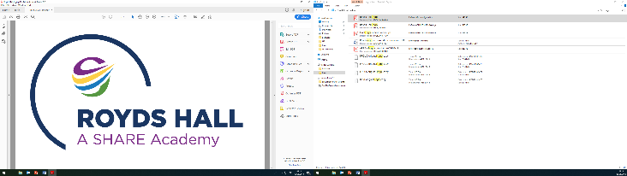

Post-16 Options:
How does it all work?

A Guide for Parents and Students

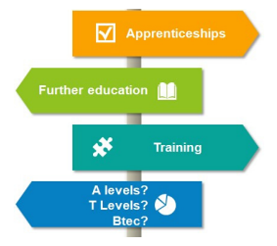

Post-16 Education – What are my options?


Since 2013, the Raising of the Participation Age law has stated that young people must be in some form of ‘education or training’ until they are 18. This can include:
Full-Time Study – this could be a qualification taken at a sixth form, college or training provider, totalling 540 hours of learning time per year, or around 18 hours per week.
Apprenticeships – this involves working for an employer while studying for a qualification as part of your training usually at a College. Usually, work makes up 80% of an apprenticeship and at least 20% (or one day a week) should be dedicated to studying.
Traineeships – this is an option for students who would like to do an apprenticeship but may not have the experience, skills or qualifications to do so yet. Traineeships can last up to six months and involve a work placement, Maths and English qualifications and support with finding an apprenticeship.
Part-Time Study with Employment or Volunteering – this could be working in a full-time job (classed as any work that takes place over more than two months and is over 20 hours per week) or volunteering (again, over 20 hours per week) while studying part-time at a college or training provider (totalling 280 hours of learning per year).
How do I pay for post-16 education and training?
Education and training in the UK are free for young people until they turn 19. In addition, there is a 16-19 Bursary Fund to help students from low income families pay for things like transport, food and stationery, which can be accessed at any sixth form, college or training provider you attend after Year 11 - www.gov.uk/1619-bursary-fund
If you receive financial benefits from the government, such as Tax Credits or Child Benefit, it is important that you are aware of how these can be affected once your child leaves school. If your child is in full-time education, such as sixth form or college, your benefits will remain the same but if your child progresses into paid employment or an apprenticeship, they will no longer be considered your dependant and your benefits for them will stop. More information can be found via the Gingerbread website: https://www.gingerbread.org.uk/information/benefits-tax-credits-and-universal-credit/money-when-your-child-turns-16/
Many organisations also have their own financial support for students, so check first!
Useful Links:
http://www.parentalguidance.org.uk/help-information/raising-the-participation-age-rpa
https://www.gov.uk/know-when-you-can-leave-school


Sixth form colleges typically focus on A-Level (Advanced Level) qualifications – two-year courses that end in an overall examination and a grade from A*-E, with a similar structure to GCSEs but looking at the subject in a lot more depth. Students can study:
Traditional A-Levels – Subjects like Biology, Chemistry, Physics, English Literature, English Language, Mathematics, Geography, History, Languages, Religious Education, Music, Art

Alternative A-Levels – Subjects like Photography, Law, Sociology, Psychology, Business Studies, Film Studies, Media Studies, Economics, Politics, Sports Science

Vocational Qualifications – Some sixth form colleges offer Vocational qualifications (For example BTEC, CACHE, CTEC and WJEC) that can be taken alongside A-Levels. These are usually made up of a number of separate modules and include practical assessments and coursework, as well as exams. Subjects can include Health and Social Care, Applied Science, Travel and Tourism, Sport and Engineering plus many more.

Students studying A-Levels usually select three or four subjects (depending on their GCSE grades) Sixth form colleges also offer something called the Extended Project Qualification (EPQ), an independent project that can provide students with UCAS points to put towards university.
Entry Requirements – Most sixth form colleges usually ask students to have 5 GCSEs at Grade 4 or above but make sure that you do your research, as some courses, such as A-Level Maths, Physics, Biology and Chemistry, require students to achieve a Grade 6 at GCSE in order to demonstrate their deeper understanding of the subject.
Some Local Options:
Greenhead college - https://www.greenhead.ac.uk/
Huddersfield New College - https://www.huddnewcoll.ac.uk/
Shelley College - https://home.shelleycollege.org/
Sixth Form Colleges
Colleges and Training Providers

Colleges and training providers usually offer BTECs or other vocational qualifications that focus on a specific area of study in a practical way
General FE Colleges – Offer everything from Hair and Beauty, Childcare and Construction, through to Business Management, Games Design, Automotive Engineering, Food Technology, Fashion Design, Performing Arts and Photography:
Kirklees College – https://www.kirkleescollege.ac.uk/
Entry Requirements:
Entry Level/Level 1 – Can require anything from no qualifications up to 3 GCSEs (any grade)
Level 2 – Usually requires 3 GCSEs at Grade 3 or above
Level 3 – Usually requires 5 GCSEs at Grade 4 or above

Apprenticeships – Involve working for an employer in a specific role while being trained to do the job by experienced staff, in a combination of on-the-job and off-the-job training at a college or training provider (this must be at least 20% of the apprenticeship). Apprenticeships must be at least one year long and all apprentices must be paid a minimum of £4.15 per hour (although many companies pay more!). Apprenticeships can now be undertaken in a variety of industries, including Engineering, Graphic Design, Software Development, Hair and Beauty and Catering (and can be started as soon as an individual turns 16 and has left full-time education, although you can apply beforehand). Apprenticeships come in four different levels:
Intermediate/Level 2 (equivalent to GCSE) – usually requires Maths/English at GCSE
Advanced/Level 3 (equivalent to A-Level) – usually requires 5 GCSEs at Grade 4+
Higher/Level 4-5 (equivalent to Foundation Degree) – usually requires L3 or A-Levels
Degree/Level 6-7 (equivalent to University Degree) – usually requires 3 A-Levels or similar
Traineeships – Opportunity for students aged 16-24 who do not have the relevant qualifications, experience or skills to start an apprenticeship but are interested in progressing on to one in the future. Traineeships involve a programme of up to six months of study, including a work placement, qualifications in Maths and English and support with finding a job or apprenticeship once the course is completed. Students are not paid for taking part but can apply for a 16-19 Bursary Fund to help with cost

Training Providers in and around Huddersfield:
White Rose Beauty College – Specialise in Hairdressing and Beauty Therapy courses – https://www.whiterosebeautycolleges.co.uk/our-colleges/leeds

The Link Training Academy – Specialise in Hair and Skills for Life. www.thelinkacademy.co.uk

Independent Training Services Ltd – A range of Level 2 and 3 Vocational courses available including Accounting, Health and Social Care and Health Care and Social work www.ind-training.co.uk

Huddersfield Textile Centre of Excellence – Offers a range of Intermediate and Advanced Apprenticeships as well as Level 2 and 3 Diplomas. www.textile-training.com

Mark Betts Hair Education – Offers NVQ Level 2 and 3 in Hair www.markbetts.co.uk/mark-betts-hair-education
- YH Training Services – Offers a range of Apprentices in Business Administration,,Customer Service,, Hospitality,, IT as well as Entry level – Level 3 Vocational Qualifications. https://www.yh-group.co.uk/

- Creative & Media Studio School - Qualifications can be achieved in A Levels, BTECs & GSCEs. Courses include Fine Art, Drama, Music, Printed Textiles, Graphic Design, Fashion, Media, Photography and Business. https://www.studio-school.org.uk/

- Kirklees College - Largest provider of apprenticeship courses in our area, offering many different skill areas. https://www.kirkleescollege.ac.uk/apprenticeships/
CITB - Construction specialist -Uses Kirklees College to deliver off the job training for some skills areas and Leeds College of Building for specialist skills https://www.citb.co.uk/courses-and-qualifications/citb-apprenticeships/

JTL - Plumbing and Electrical specialists -Uses Kirklees College to deliver off the job training https://www.jtltraining.com/

National Business College – Offers Apprenticeships in Business Administration and IT https://nationalbusinesscollege.co.uk/

Woodspeen Training - Offers a range of skills areas, from IT, Childcare, Hairdressing https://www.woodspeen.co.uk/
Other useful https://amazingapprenticeships.com/
http://www.apprenticeshipguide.co.uk/
https://www.gov.uk/government/publication/a-parents-guide-to-apprenticeships
Useful Links:
www.ckcareersonline.org.uk
www.gov.uk/apply-apprenticeship
Maths and English resits – What are the rules?
It is important to remember that if you get lower than a Grade 4 in your GCSE Maths and English exams, you will need to re-sit these qualifications as part of any course you study at college or as part of an apprenticeship. It is nothing to worry about, as the college or training provider will help you with studying for these qualifications or if necessary, get you to complete an alternative qualification called Functional Skills Maths and English, which is available for any students who achieve lower than a Grade 3 in their GCSE Maths/English.


T Levels are new courses coming in September 2020, which will follow GCSEs and will be equivalent to 3 A Levels. These 2-year courses have been developed in collaboration with employers and businesses so that the content meets the needs of industry and prepares students for work.
T Levels will offer students a mixture of classroom learning and ‘on-the-job’ experience during an industry placement of at least 315 hours (approximately 45 days). They will provide the knowledge and experience needed to open the door into skilled employment, further study or a higher apprenticeship.
For more information on T-Levels, check out the link below:
https://www.gov.uk/government/publications/introduction-of-t-levels/introduction-of-t-levels

Applying for post-16 – How does it work?

Students will begin applying for their post-16 options in Autumn 2021 and the application process for sixth form, college and apprenticeships takes place throughout the course of the academic year. Here is a projected timeline for 2021-22:
September 2022 – February 2023 – Students will receive a 1 to 1 personal guidance interview with our school Career Advisor.
September 2022 – Students will be preparing their personal statements in Personal Development time along with exploring post 16 options.

October 2022 – Sixth form and college courses for 2022-23 visible on Get Into application sites.

October 2022 – February 2023 – Students complete their college application forms ensuring they have applied to at least two post 16 providers.

January / February 2023 – Closing date for sixth form applications
NOTE: Colleges do not have the same deadlines but early applications are still advised.

January 2023 – Students will have the opportunity to have a Mock interview with an external employer and will be given feedback on this interview.

March/April 2023 – Students are invited to sixth form/college interviews.

March 2023 onwards – Students begin to receive offers from sixth forms and colleges.

March-July 2023 – Students accept or reject offers for different courses.

NOTE: Apprenticeship and Traineeship applications run throughout the academic year and students must be 16 and have finished full-time education before starting. Apprenticeships have a much more detailed application process than sixth form or college and may require students to find their own placements if taken via colleges.

Students will apply for the majority of sixth form and college courses (and even some apprenticeships) using the GET into Application System which was launched in September 2019.
The GET into Application Systems work as a platform for both searching and applying for courses – the Personal Development teachers along with the school Careers Adviser will be running a training session with all Year 11 students in September in order to give them their GET into Application System login details and help them to complete their profiles for the website, as well as providing advice on how to write a personal statement and complete their applications. The main areas students will need to fill in on these types of application will usually be:
- Personal Details e.g. name, address, contact email/number etc.
- Qualifications e.g. predicted grades for their GCSE and/or BTEC subjects.
- Work History e.g. details about any work experience or volunteering completed.
- Personal Statement e.g. telling the sixth form/college more about themselves.
- Post 16 choices e.g the subjects they want to study and the Level.
- Reference – provided by the school to comment on attendance, behaviour etc.

Preparing Your Safety Net

Although many students achieve the grades that they want from their GCSE examinations, it is important to prepare a back-up option in case students change their minds about what subjects they want to study or are unsuccessful in getting the grades required in order to progress on to their college/apprenticeship/course of choice.
The great news is that students can apply and accept offers from as many sixth forms, colleges and training providers as they want and can then make their mind up about which one they want to progress on to in September after visiting the environment, meeting the staff and finding out what GCSE grades they have received in August 2023
REMEMBER – Always prepare your ‘Safety Net’!

Entry Requirements – What do I need to get in?

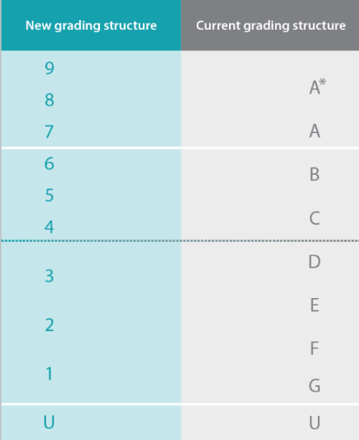
Below is the GCSE grading system, take a look at the information below to make sure you know what grades you might need to get at GCSE in order to move on to your chosen destination after Year 11:
Key Points:
- A Grade 4 is a Standard Pass, while a Grade 5 is a Strong Pass
- Only around 2-3% of students will achieve a Grade 9, making it a little higher than the old A*
- Although the new grades don’t exactly match the old grades, colleges will mostly view them as follows:

9-7 = A*- A 6 = B 4-5 = C 3-1 = D and below
- Vocational qualifications like BTEC and VCERT match up with GCSEs as follows:
L1 = GCSE grades 1-3 (Pass - Distinction)
L2 = GCSE grades 4-9 (Pass – Distinction)
- Most colleges, sixth forms and apprenticeships accept BTEC-type qualifications, as do 95% of universities, including the Russell Group and Oxford!
No matter what you read online, it is important to check all information carefully. Although the Department for Education have stated that a Grade 4 will be considered the official ‘Pass Mark’ for students, not all colleges or universities may agree with this. For example, Kings College London and UCL both now ask for a Grade 5 at GCSE in English and Maths as part of their entry requirements, but Manchester, Leeds and Liverpool (all Russell Group universities) still consider Grade 4 the equivalent to a C.
As stated above, different post-16 and post-18 pathways may ask for different entry requirements depending on the course and/or college. For example, some apprenticeships require only GCSE English and Maths at Grade 3 and above, while some sixth form colleges ask for a Grade 5/6 in the subject students are wanting to take up from GCSE to A-Level. Using the following websites can help you to find the exact entry requirements you need:
START PLATFORM https://app.startprofile.com/what-to-study Hot Courses - https://www.hotcourses.com/ Some useful references:
Which University – How important are my GCSEs? https://university.which.co.uk/advice/gcse-choices-university/how-important-are-my-gcse-grades
Ofqual - https://ofqual.blog.gov.uk/2018/03/02/gcse-9-to-1-grades-a-brief-guide-for-parents/

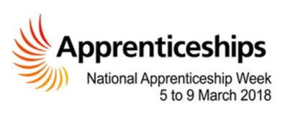
Qualification Levels Guide – GCSE to Degree Level
Key Points:
- A Grade 4 is a Standard Pass, while a Grade 5 is a Strong Pass
- Only around 2-3% of students will achieve a Grade 9, making it a little higher than the old A*
- Although the new grades don’t exactly match the old grades, colleges will mostly view them as follows:

9-7 = A*- A 6 = B 4-5 = C 3-1 = D and below
- Vocational qualifications like BTEC and VCERT match up with GCSEs as follows:
L1 = GCSE grades 1-3 (Pass - Distinction)
L2 = GCSE grades 4-9 (Pass – Distinction)
- Most colleges, sixth forms and apprenticeships accept BTEC-type qualifications, as do 95% of universities, including the Russell Group and Oxford!
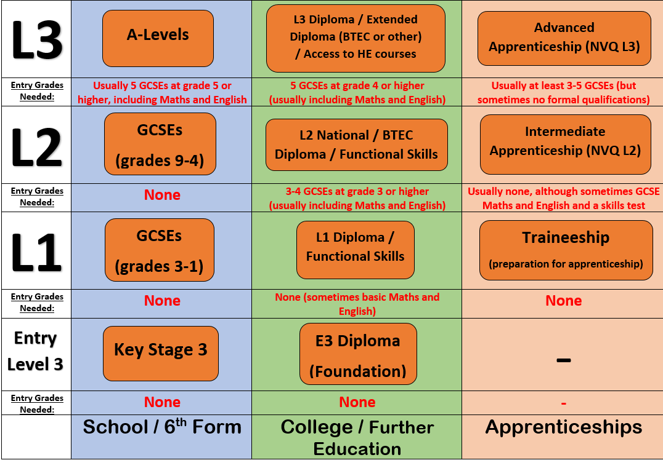
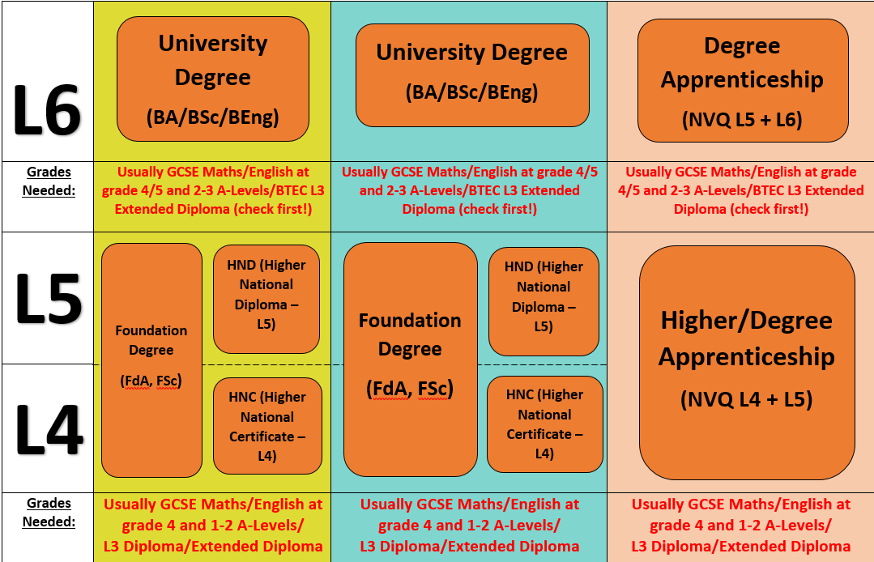
How do I make my final decision about post-16?

Making a decision about where to go after Year 11 can be tricky, particularly while you are busy revising for your final GCSE exams, so it is important to consider the following factors that might can help with decision making:
- Where can this option take me in the future? If you are thinking about a destination after post-16, such as university or higher/degree apprenticeships, it is important to know whether the qualifications you are taking from 16-18 can help you to progress on to these pathways. Use websites like the Russell Group’s Informed Choices (https://www.informedchoices.ac.uk/) or Success at School (https://successatschool.org/) to find out whether the course you choose after Y11 will allow you to progress on to what you want to do or speak with staff at the sixth form, college or apprenticeship you are applying to in order to get further details
- What will doing this option be like? Whatever you choose to do after Year 11, you will probably be doing it for at least one year, so it is important that you know that the learning environment and style of learning will be right for you. Why not…

Speak to sixth form or college staff and students at one of the many Open Days or Open Evenings that take place throughout the year – the websites for each sixth form or college will have these dates.
START PROFILE 
Use the START Profile to research more about the sixth form, college or apprenticeship provider and to find out about where to learn and the different courses and qualifications each provider offers. https://app.startprofile.com/options/where-could-i-learn

The school Careers Adviser will be working with all Year 11 students from September but you can also email her on Natalie.Schofield@Sharemat.co.uk with any questions

